**1a. A Use case diagram for our application**

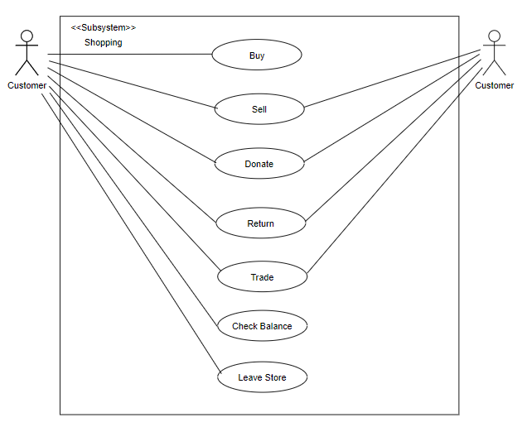

**1b. Use Case Specifications**

**First Use Case (Buy):**

**Use Case Description: Allows user to make purchases from the Merchant. This use case begins when a customer chooses to buy an item from a menu of different options provided that they have a sufficient amount in their wallet. The item is then sold and added to the customers bag.**

**Actors:**

* **Any Merchant Customer (Has sufficient money).**
* **Merchant.**

**Triggers:**

* **The User wants to buy an item.**

**Preconditions:**

* **The Merchant is open.**
* **The customer has sufficient funds.**

**Post Conditions:**

* **The Merchant Customer has bought their item.**
* **The Merchant has recorded details of the transaction.**

**Normal Flow:**

1. **The customer began the Online Merchant experience.**
2. **The Merchant requests a choice from the customer.**
3. **The customer chooses to buy an item.**
4. **The Merchant adds that item to the customers bag provided that they have the money.**
5. **The Merchant requests a choice from the customer.**
6. **The customer chooses to leave the store.**

**Second Use Case (Sell):**

**Use Case Description: Allows user to sell items to the Merchant. This use case begins when a customer chooses to sell item from a menu of different options. The user is then asked to input the amount of the item they would like to sell. If an item is sold, that amount is then added to the user’s wallet.**

**Actors:**

* **Any Merchant Customer**
* **Merchant.**

**Triggers:**

* **The customer wants to sell an item.**

**Preconditions:**

* **The Merchant is open.**
* **The customer has item to sell**

**Post Conditions:**

* **The Customer has sold their item and wallet has been incremented**
* **The Merchant has recorded details of the transaction.**

**Normal Flow:**

1. **The customer began the Online Merchant experience.**
2. **The Merchant requests a choice from the customer.**
3. **The customer chooses to sell an item.**
4. **The Merchant requests for the type and price of item the customer would like to sell.**
5. **The customer enters the item and the price of the item.**
6. **The Merchant collects the item and adds the price of the item to the Customers wallet.**
7. **The Merchant requests a choice from the customer.**
8. **The customer chooses to leave the store.**

**Third Use Case (Donate):**

**Use Case Description: Allows user to donate items to the Merchant. This use case begins when a customer chooses to donate item from a menu of different options. The user is then asked to enter the item they would like to donate, after which the item is successfully donated.**

**Actors:**

* **Any Merchant Customer**
* **Merchant.**

**Triggers:**

* **The customer wants to donate an item.**

**Preconditions:**

* **The Merchant is open.**
* **The customer has item to donate**

**Post Conditions:**

* **The Merchant Customer has donated their item.**
* **The Merchant has recorded details of the transaction.**

**Normal Flow:**

1. **The customer began the Online Merchant experience.**
2. **The Merchant requests a choice from the customer.**
3. **The customer chooses to donate an item.**
4. **The Merchant requests for the type of item they would like to donate.**
5. **The customer enters the item.**
6. **The Merchant collects the item.**
7. **The Merchant requests a choice from the customer.**
8. **The customer chooses to leave the store.**

**Fourth Use Case (Return):**

**Use Case Description: Allows user to return items to the Merchant. This use case begins when a customer chooses to return item from a menu of different options. Provided that the item was bought from the same store, the merchant shows the items the customer bought and requests which one they would like to return. If an item is returned, the amount of that item is then added back to the user’s wallet.**

**Actors:**

* **Any Merchant Customer**
* **Merchant.**

**Triggers:**

* **The customer wants to return an item.**

**Preconditions:**

* **The Merchant is open.**
* **The customer bought the item from the same merchant and would like to return it.**

**Post Conditions:**

* **The Merchant Customer has returned their item and wallet has been incremented**
* **The Merchant has recorded details of the transaction.**

**Normal Flow:**

1. **The customer began the Online Merchant experience.**
2. **The Merchant requests a choice from the customer.**
3. **The customer chooses to return an item.**
4. **If multiple items were bought from the merchant, the merchant shows the items to the customer and asks which item they would like to return.**
5. **The customer enters the item**
6. **The Merchant collects the item and adds the price of the item to the Customers wallet.**
7. **The Merchant requests a choice from the customer.**
8. **The customer chooses to leave the store.**

**Fifth Use Case (Trade):**

**Use Case Description: Allows user to Trade items with the Merchant. This use case begins when a customer chooses to trade item from a menu of different options. Provided that the user has an item to trade, the merchant requests the item, the price of the item they would like to trade, and the item they would like to trade said item for. If an item is traded, based on the amount, the deductions or results are added or subtracted from customers wallet.**

**Actors:**

* **Any Merchant Customer**
* **Merchant.**

**Triggers:**

* **The customer wants to trade an item.**

**Preconditions:**

* **The Merchant is open.**
* **The customer has an item they would like to trade.**

**Post Conditions:**

* **The Merchant Customer has traded their item and wallet has been incremented or decremented.**
* **The Merchant has recorded details of the transaction.**

**Normal Flow:**

1. **The customer began the Online Merchant experience.**
2. **The Merchant requests a choice from the customer.**
3. **The customer chooses to trade an item.**
4. **The Merchant requests the item and price of the item the customer would like to trade.**
5. **The customer enters the item and the price.**
6. **The Merchant collects the item and calculates deductions or reimbursement to be added to the customers wallet.**
7. **The Merchant requests a choice from the customer.**
8. **The customer chooses to leave the store.**

**Sixth Use Case (Check Balance):**

**Use Case Description: Allows user to Check the balance in their wallet. This use case begins when a customer chooses to check their balance from a menu of different options. The customers balance is calculated and shown to the customer.**

**Actors:**

* **Any Merchant Customer**
* **Merchant.**

**Triggers:**

* **The customer wants to check their balance.**

**Preconditions:**

* **The Merchant is open.**
* **The customer has made recent transactions**

**Post Conditions:**

* **The Merchant Customer has checked their balance**
* **The Merchant has recorded details of the transaction.**

**Normal Flow:**

1. **The customer began the Online Merchant experience.**
2. **The Merchant requests a choice from the customer.**
3. **The customer chooses to check their balance.**
4. **If recent transactions have been made, the balance is calculated.**
5. **The balance is shown to the user.**
6. **The Merchant requests a choice from the customer.**
7. **The customer chooses to leave the store.**

**Seventh Use Case (Check Balance):**

**Use Case Description: Allows user to leave the store after they decide they are done. This use case begins when a customer chooses to leave the store, after which a nice goodbye message is shown to the user.**

**Actors:**

* **Any Merchant Customer**
* **Merchant.**

**Triggers:**

* **The customer is done with any transactions.**

**Preconditions:**

* **The Merchant is open.**
* **The customer began the online Merchant experience**

**Post Conditions:**

* **The Merchant Customer has checked their balance**
* **The Merchant has recorded details of the transaction.**

**Normal Flow:**

1. **The customer began the Online Merchant experience.**
2. **The Merchant requests a choice from the customer.**
3. **The customer chooses to leave the store.**
4. **A goodbye message is shown to the Customer.**